BICYCLE PRE-BOOKING FORM
PLAYITAS CYCLE CENTRE 01.11.2019 – 30.04.2020

RENT PRICES FOR BIKES
Normal pedals or upon availability (SPD & SPD SL, LOOK KEO), hand pump, saddle bag with spare tube and tire levers included.
Insurance is not included (price is 3€ /day).

ROAD BIKES

BOOKING PERIOD | BMC SLR 3 | BMC SLR 2 DI2 | BMC TIME MACHINE DI2
1-5 days (Price per day | €35 | €45 | €62
6 days | €176 | €227 | €313
1 week | €189 | €243 | €334
2 weeks | €324 | €416 | €573
Extra Day to  package | €28 | €36 | €52

MOUNTAIN BIKE *FITNESS BIKE

1 day | €29 | €20
Extra day to  package | €24 | €18
3 days | €72 | €50
1 week | €156 | €104
2 weeks | €268 | €184

FAT BIKE

1 day | €29
*JOGGERS *KIDS KICK BIKES

1 day | €10 | €5
* Direct booking in cycle center.

The minimum period in order to make a reservation in advance is 6 consecutive days of rental. Payment must be made within 5 days after making the reservation!
Please note that should you hire a bike from another hire company you will not be able to join any of our bike tours due to insurance purposes.

CANCELLATION COSTS:
More than 30 days before arrival free of charge
Up to 15 days before arrival 50% charge of the total amount Up to 5 days before arrival 75% charge of the total amount 5 - 0 days before arrival 100% charge of the total amount

NAME*
EMAIL/TELEPHONE*

BOOKED ACCOMMODATION* (Only guests of Playitas Resort can book a bike!)

PLEASE TELL US YOUR HIRE DATES *:

FIRST DAY OF HIRE (DD/MM/YY)* :
LAST DAY OF HIRE ( DD/MM/YY)* :
DAY OF ARRIVAL ( DD/MM/YY)*: DAY OF DEPARTURE (DD/MM/YY)*:

*Mandatory

SELECT THE BIKE AND THE SIZE CORRESPONDING TO YOUR BODY HEIGHT
With the following booking request form you can book your bike in advance. Please navigate using your mouse to click on the boxes, or use the TAB key. Place an X to indicate your choice of bicycle type, and size, based on your height.
Please inform us about your body height

BMC SLR3 (RB)
Frame: Fork: Shifters: Wheels:

Total Carbon Carbon
Shimano Ultegra Compact 2x11 Shimano RS

XS  Under -  160 | S 160-170 | M 170-180 | L 180-190 | XL  above 190

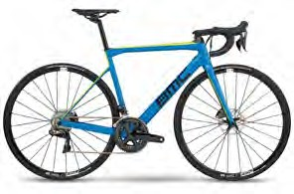
Frame: Fork: Shifters: Wheels:
BMC SLR02 DI2 (RB)
Total Carbon Carbon
Shimano Ultegra Di2 2x11 DT Swiss

XS  Under - 160 | S 160-170 | M 170-180 | L 180-185 | XL  Above 185

BMC TIME MACHINE DI2 (RB)

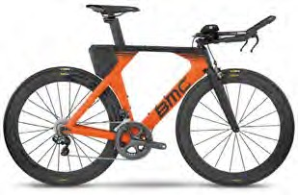
Frame: Fork: Shifters: Wheels:
Total Carbon Carbon
Shimano Ultegra Di2 2x11 Mavic CXR Elite

XS  Under - 160 | S 160-170 | M 170-180 | L 180-190

BMC Team Elite 03 (MTB)
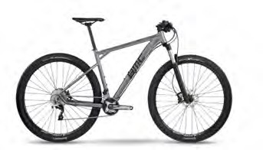
Frame: Al-13 Premium Triple-butted Hydroformed Aluminum
Fork: Rockshox Recon Gold RL,Solo Air, Remote Shimano Xt/SLX/Deore/M677
Shifters: Shimano SLX
Wheels: DT Swiss.

S  under 170 |  | M 170-  180 |  | L 180-185 |  | XL  above 185
 | 29” |  | 29” |  | 29” | 29”

FAT BIKES

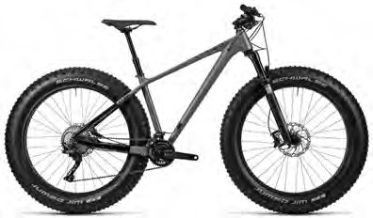
Frame: HPA Superlite, Advanced Hydroforming, Triple Butted, ARG, Tapered Head Tube, Internal Cable Routing

Shifters: Shimano XT SL-M8000-I, Direct Attach Tires: Schwalbe Jumbo Jim Kevlar, 4.40"

S | M | L | XL
15¨ | 17¨ | 19¨ | 21¨

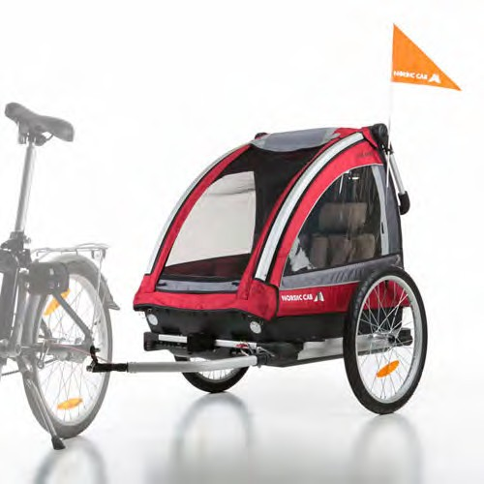
KIDS KICK BIKE JOGGERS
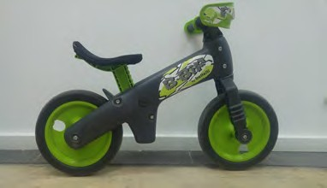

Payment method:
Credit Card: Bank Transfer:

BOOKING INFORMATION
It is recommended that you book in advance. There is no guarantee of availability. The minimum period in order to make a reservation in advance is 6 consecutive days of rental.
We kindly remind you that bike bookings are only possible for guests of Playitas Resort. To make a reservation please send the filled out booking form to: bike@playitas.net

PRIVACY POLICY

In compliance with the Data Protection Act 15/1999 concerning the rights governing the use of personal data, the SOTAVENTO SAU based in Las Playitas, Playitas Hotel (CIF-A-35017706, Playitas Resort, 35629 Tuineje, in the following named the company) informs you that all personal data sent with this formula is collected in a confidential database and solely used for the purpose of managing the contractual relationship between the parties including all aspects corresponding to the processing of personal data.
At any time you can use your right to access, correct or delete your data, or to object to the use of your data. In this case, please send a written request together with a copy of your identity card or similar proof of identity to the above mentioned address or via email to info@playitas.net.
Moreover, hereby you explicitly agree with the transfer of your personal data by SOTAVENTO SAU to the company or companies being involved in related services and managing your data.

